You’re Invited!

Celebrate the season with music, community, and cheer!
Holiday Lights
Saturday, December 19 • 3:00 PM
Greenbelt Community Center Gym
Enjoy festive favorites, winter classics, and a touch of holiday sparkle.

All ages are welcome — bring family and friends for this free holiday performance.

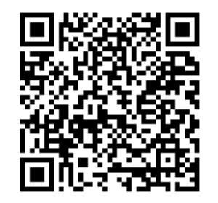
Help keep the music playing! Support the Greenbelt Concert Band—donate via Zeffy to maintain instruments & buy new music.
Learn more: greenbeltconcertband.org
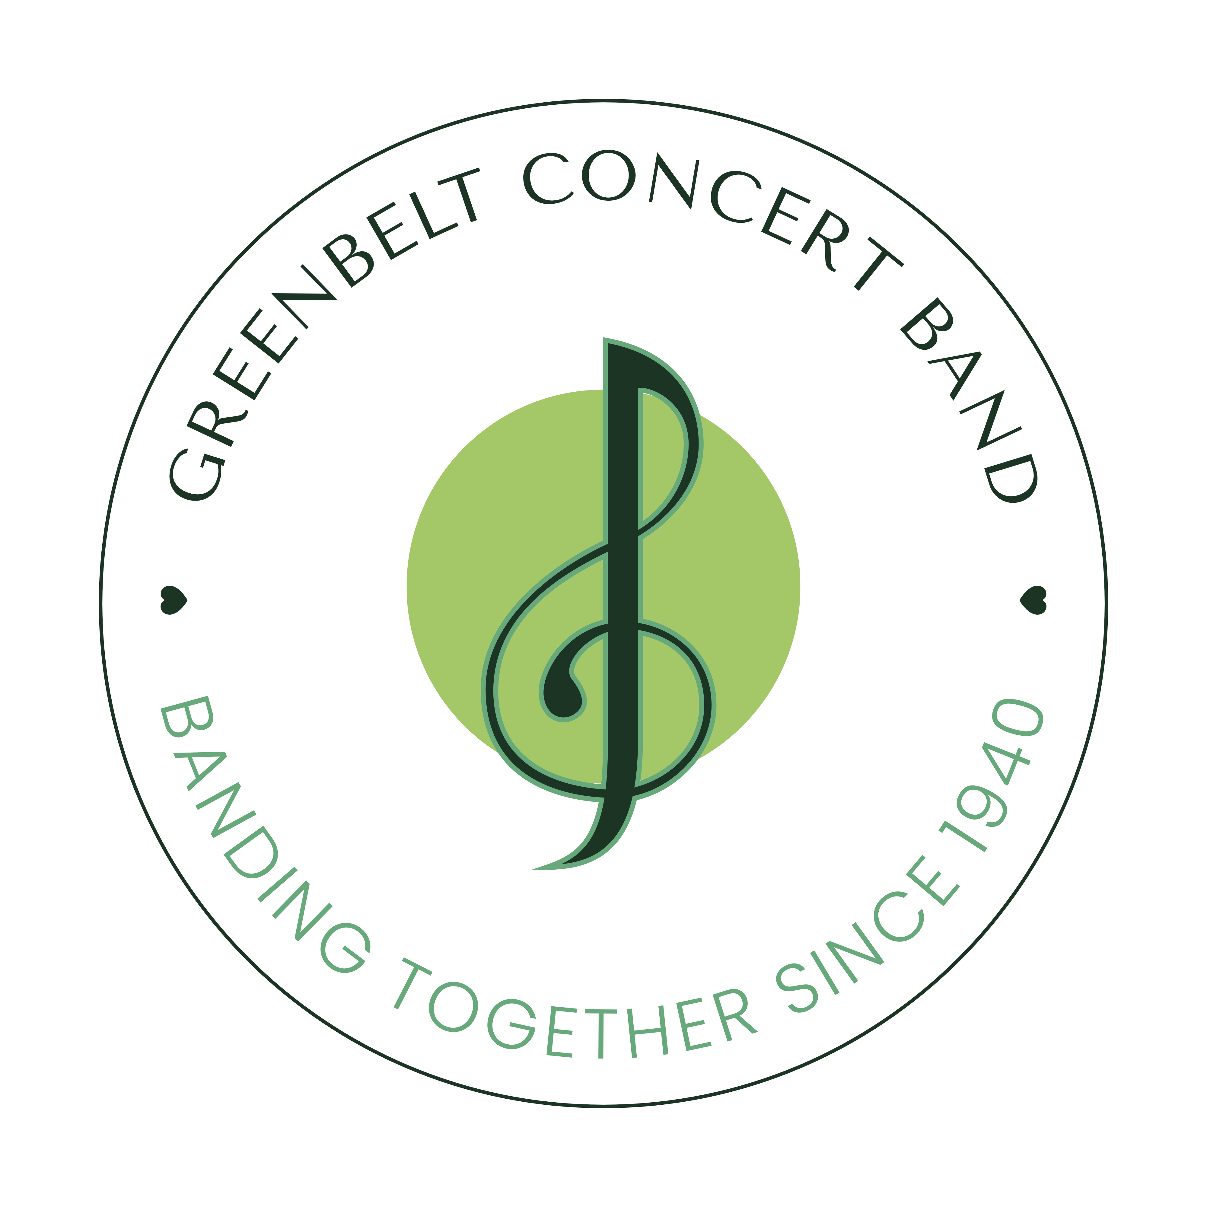
Zeffy QR Code

