You’re Invited!

Greenbelt Concert Band Winter Concert 2026
Celebrate the season with music, community, and cheer!
All ages are welcome — bring family and friends for this joyful free holiday performance.
Festival of Lights Concert
Monday, December 7 • 6:30 PM
Washington D.C. Temple Visitors’ Center (Mormon Visitors’ Center)
Experience the magic of music and lights in this inspiring holiday event.
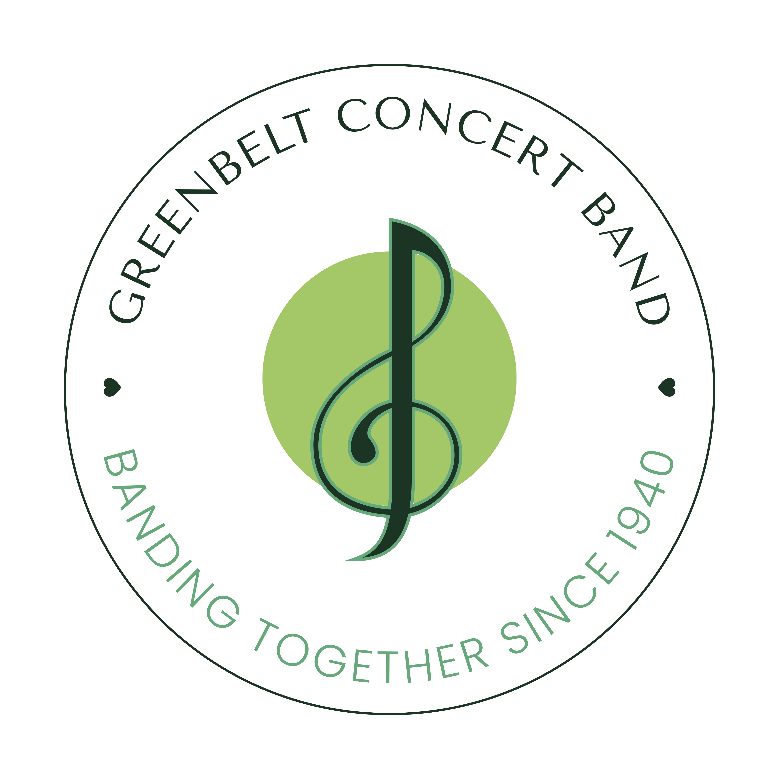
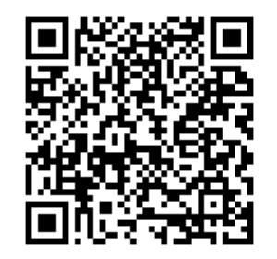
Help keep the music playing! Support the Greenbelt Concert Band—donate via Zeffy to maintain instruments, buy new music, and fuel live performances.
Zeffy QR Code
greenbeltconcertband.org

